Daily Stand-Up Meeting
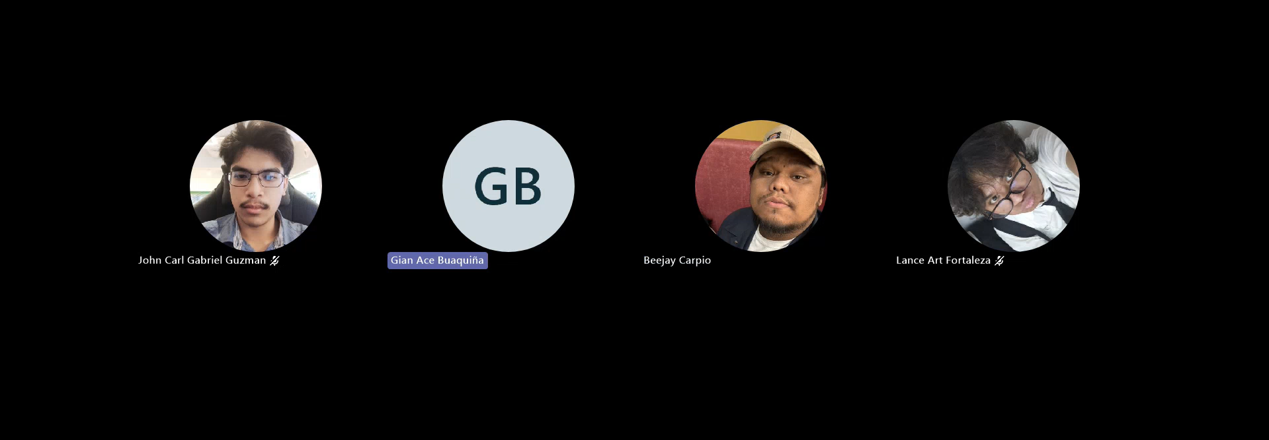

Minutes of Meeting
Date: 09/24/2026
Meeting Called By: Cache Flow
Meeting Link: Daily Stand-Up Meeting-20260924_190852-Meeting Recording.mp4

Attendees
Gian Ace Buaquiña
Beejay A. Carpio
Lance Art P. Fortaleza
John Carl Gabriel Guzman

Summary
The meeting was verifying that the Koha backend REST API is properly integrated with the frontend library catalog to support basic book search and read operations for student and faculty views. The team discussed UI customization, agreeing to adopt the official library color scheme while creating an original UI layout rather than strictly mimicking the existing portal. A temporary deployment will be hosted on Vercel for prototype testing, while final deployment will be migrated to Proxmox. Beejay updated the Use Case Diagram (UCD) and fully dressed use cases based on Sir Sean's feedback and will proceed with activity diagrams and ERD revisions. The team also planned to coordinate an online consultation with the client, Ms. April, to review current UI progress and align features with client expectations.

What we did yesterday
- Beejay A. Carpio: Completed activity diagrams for student and faculty workflows, consulted Sir Sean regarding UCD revisions, and prepared updated user story documentation.
- Gian Ace Buaquiña: Finalized Koha configuration on VirtualBox, completed backend REST API connection logic to Lira, and pushed updates to the official repository dev branch.
- Lance Art P. Fortaleza: Created and populated the official dev branch, added the Microsoft SSO login placeholder page, and structured book catalog category/detail views.
- John Carl Gabriel Guzman: Minutes of Meeting (MOM) for Day 8 and the Sir Jojo consultation meeting, assisted team members on development tasks.

What we did today
- Beejay A. Carpio: Revised the Use Case Diagram (UCD) and fully dressed use cases based on Sir Sean's feedback, updated the project backlog on Teams/SharePoint, and began drafting per-use-case activity diagrams.
- Gian Ace Buaquiña: Tested Koha REST API book read operations, configured backlog task tracking/story point hours, and prepared Koha CRUD functionality for student catalog testing.
- Lance Art P. Fortaleza: Refined student catalog UI components, replaced default user greetings with dynamic placeholders, and configured prototype hosting setup on Vercel.
- John Carl Gabriel Guzman: Did the Minutes of Meeting (MOM) for Day 9 and for the weekly status report with Sir Edward assisted team members on sprint tasks.

